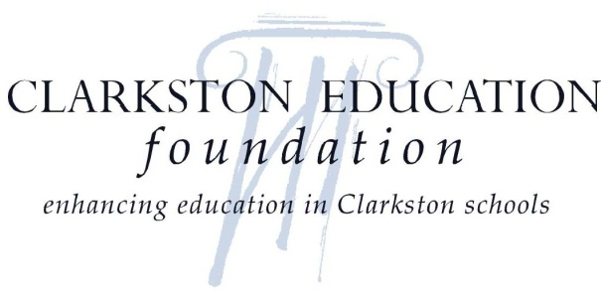

November 30, 2016

Dear Career Fair Participant:

The Washington State University GEAR UP Program at the Clarkston School District in partnership with the Clarkston Education Foundation (CEF) and Clarkston High School (CHS) will host the annual Clarkston High School GEAR UP Career Fair on February 1, 2017, from 8:15 AM to 2:30 PM in the Clarkston High School main gym.

We would like to invite you and/or your staff to attend this special event. Tables will be set up throughout the gym for career representatives to meet and speak with students. We encourage your participation and hope you share the variety of careers awaiting our students in the workforce. Specific details are included in the enclosed Registration Form.

The career fair fits nicely into the high school setting as the school is now required to assist all students with a “high school and beyond plan,” which is a State of Washington graduation requirement. Students will receive firsthand information at the career fair to help them choose a career path and meet this requirement.

Prior to the event, Clarkston High School students will have taken career planning surveys/inventories to assist them in discovering their own interests, talents, and values. The Career Fair is an amazing opportunity for our students to speak with real people about the specific career pathways that interest them.

Students will want to hear the educational path (high school, vocational/technical, college) that facilitated your success in your chosen field. We would like you to share your daily work life, salary range, and long term career opportunities for your specific field of work with our students.

Our world is changing faster than ever and new technologies are affecting how we work, learn, and communicate. With these changes, new and exciting opportunities are presented in education and the world of work. We welcome your participation in our Career Fair and hope you foresee the event as an opportunity to positively impact the lives and future of our students. Please complete the enclosed form, so we can reserve a space for you.

Please visit the website www.clarkstoneducationfoundation.org to share in the successes of CEF and/or to make a financial contribution. We thank you for your commitment in helping us shape the future for our students.

Sincerely,

Patrick Sobotta Carlos Gonzalez Chris Bunce
Site Manager, WSU GEAR UP Principal, CHS President, CEF

Clarkston High School  401 Chestnut Street  Clarkston, WA 99403  509.758.5591

